In this project, you'll build an app that will search for Pokémon by name or ID and display the results to the user. To retrieve the Pokémon data and images, you'll use freeCodeCamp's [PokéAPI Proxy](https://pokeapi-proxy.freecodecamp.rocks/" \t "_blank).

**Note:** The first 13 steps must be completed inside the index.html file.

**Objective:** Build an app that is functionally similar to [https://pokemon-search-app.freecodecamp.rocks](https://pokemon-search-app.freecodecamp.rocks/)

**User Stories:**

1. You should have an input element with an id of "search-input"
2. You should have a button element with an id of "search-button"
3. You should have an element with an id of "pokemon-name"
4. You should have an element with an id of "pokemon-id"
5. You should have an element with an id of "weight"
6. You should have an element with an id of "height"
7. You should have an element with an id of "types"
8. You should have an element with an id of "hp"
9. You should have an element with an id of "attack"
10. You should have an element with an id of "defense"
11. You should have an element with an id of "special-attack"
12. You should have an element with an id of "special-defense"
13. You should have an element with an id of "speed"
14. When the #search-input element contains the value Red and the #search-button element is clicked, an alert should appear with the text "Pokémon not found"
15. When the #search-input element contains the value Pikachu and the #search-button element is clicked, the values in the #pokemon-name, #pokemon-id, #weight, #height, #hp, #attack, #defense, #special-attack, #special-defense, and #speed elements should be PIKACHU, #25 or 25, Weight: 60 or 60, Height: 4 or 4, 35, 55, 40, 50, 50, and 90, respectively
16. When the #search-input element contains the value Pikachu and the #search-button element is clicked, you should add an img element with the id of "sprite" and the src set to the Pokémon's front\_default sprite to the page
17. When the #search-input element contains the value Pikachu and the #search-button element is clicked, the #types element should contain a single inner element with the value ELECTRIC. The #types element content should be cleared between searches
18. When the #search-input element contains the value 94 and the #search-button element is clicked, the values in the #pokemon-name, #pokemon-id, #weight, #height, #hp, #attack, #defense, #special-attack, #special-defense, and #speedelements should be GENGAR, #94 or 94, Weight: 405 or 405, Height: 15 or 15, 60, 65, 60, 130, 75, and 110, respectively
19. When the #search-input element contains the value 94 and the #search-button element is clicked, you should add an img element with the id of sprite and the src set to the Pokémon's front\_default sprite to the page
20. When the #search-input element contains the value 94 and the #search-button element is clicked, the #types element should contain two inner elements with the text values GHOST and POISON, respectively. The #types element content should be cleared between searches

Fulfill the user stories and pass all the tests below to complete this project. Give it your own personal style. Happy Coding!

**Note:** When running the tests there will be a slight delay. Please wait a few seconds to allow the tests to finish. Do not refresh the page before they are done.

TESTS

* 1. You should have an input element with an id of "search-input" and is **required**.
* Waiting:2. You should have a button element with an id of "search-button".
* Waiting:3. You should have an element with an id of "pokemon-name".
* Waiting:4. You should have an element with an id of "pokemon-id".
* Waiting:5. You should have an element with an id of "weight".
* Waiting:6. You should have an element with an id of "height".
* Waiting:7. You should have an element with an id of "types".
* Waiting:8. You should have an element with an id of "hp".
* Waiting:9. You should have an element with an id of "attack".
* Waiting:10. You should have an element with an id of "defense".
* Waiting:11. You should have an element with an id of "special-attack".
* Waiting:12. You should have an element with an id of "special-defense".
* Waiting:13. You should have an element with an id of "speed".
* Waiting:14. When the #search-input element contains the value Red and the #search-button element is clicked, an alert should appear with the text "Pokémon not found".
* Waiting:15. When the #search-input element contains the value Pikachu and the #search-button element is clicked, the values in the #pokemon-name, #pokemon-id, #weight, #height, #hp, #attack, #defense, #special-attack, #special-defense, and #speed elements should be PIKACHU, #25 or 25, Weight: 60 or 60, Height: 4 or 4, 35, 55, 40, 50, 50, and 90, respectively.
* Waiting:16. When the #search-input element contains the value Pikachu and the #search-button element is clicked, you should add an img element with the id of "sprite" and the src set to the Pokémon's front\_default sprite to the page.
* Waiting:17. When the #search-input element contains the value Pikachu and the #search-button element is clicked, the #types element should contain a single inner element with the value ELECTRIC. Make sure the #types element content is cleared between searches.
* Waiting:18. When the #search-input element contains the value 94 and the #search-button element is clicked, the values in the #pokemon-name, #pokemon-id, #weight, #height, #hp, #attack, #defense, #special-attack, #special-defense, and #speed elements should be GENGAR, #94 or 94, Weight: 405 or 405, Height: 15 or 15, 60, 65, 60, 130, 75, and 110, respectively.
* Waiting:19. When the #search-input element contains the value 94 and the #search-button element is clicked, you should add an img element with the id of "sprite" and the src set to the Pokémon's front\_default sprite to the page.
* Waiting:20. When the #search-input element contains the value 94 and the #search-button element is clicked, the #types element should contain two inner elements with the text values GHOST and POISON, respectively. Make sure the #types element content is cleared between searches.
* Waiting:21. When the #search-input element contains an invalid Pokemon name and the #search-button element is clicked, an alert should appear with the text "Pokémon not found".
* Waiting:22. When the #search-input element contains a valid Pokemon id and the #search-button element is clicked, the UI should be filled with the correct data.

**PokéAPI Proxy**

**Usage**

Use the endpoint https://pokeapi-proxy.freecodecamp.rocks/api/pokemon to see a list of all valid Pokémon names, id numbers, and URLs.

Use the endpoint https://pokeapi-proxy.freecodecamp.rocks/api/pokemon/{name-or-id} to get data for a Pokémon, where {name-or-id} is the Pokémon's name or id number.

Note: Pokémon names should be in lowercase, have special characters removed, and be dash separated. Also, if the Pokémon has either ♀ or ♂ as part of its name, the format is {name-f} or {name-m}, respectively.

**Example Requests**

Click any of the example requests below to see its response.

**All valid Pokémon:**

* <https://pokeapi-proxy.freecodecamp.rocks/api/pokemon>

**Pikachu:**

* <https://pokeapi-proxy.freecodecamp.rocks/api/pokemon/pikachu>
* <https://pokeapi-proxy.freecodecamp.rocks/api/pokemon/25>

**Nidoran♀:**

* <https://pokeapi-proxy.freecodecamp.rocks/api/pokemon/nidoran-f>
* <https://pokeapi-proxy.freecodecamp.rocks/api/pokemon/29>

**Mr. Mime:**

* <https://pokeapi-proxy.freecodecamp.rocks/api/pokemon/mr-mime>
* 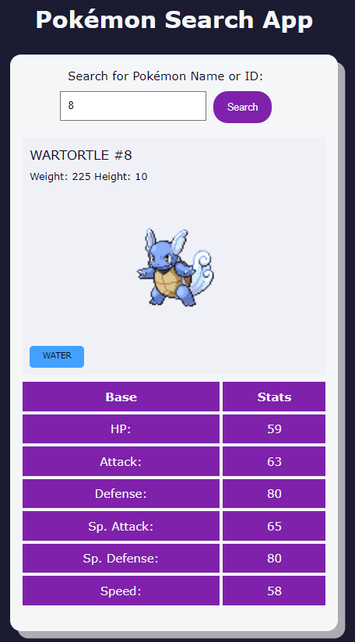<https://pokeapi-proxy.freecodecamp.rocks/api/pokemon/122>